Leigh High School
Performing Arts Parents Association

Minutes of Regular Membership Monthly Meeting
Meeting Date: Monday December 10, 2018
Called to Order: 7:05 pm
Attendees: 19
Conducted By: Stacey Taylor, President
Minutes: Kristine Grim, Secretary

Minutes: Sonia motioned to approve October and November minutes as written. Joe seconded. Motion carried.
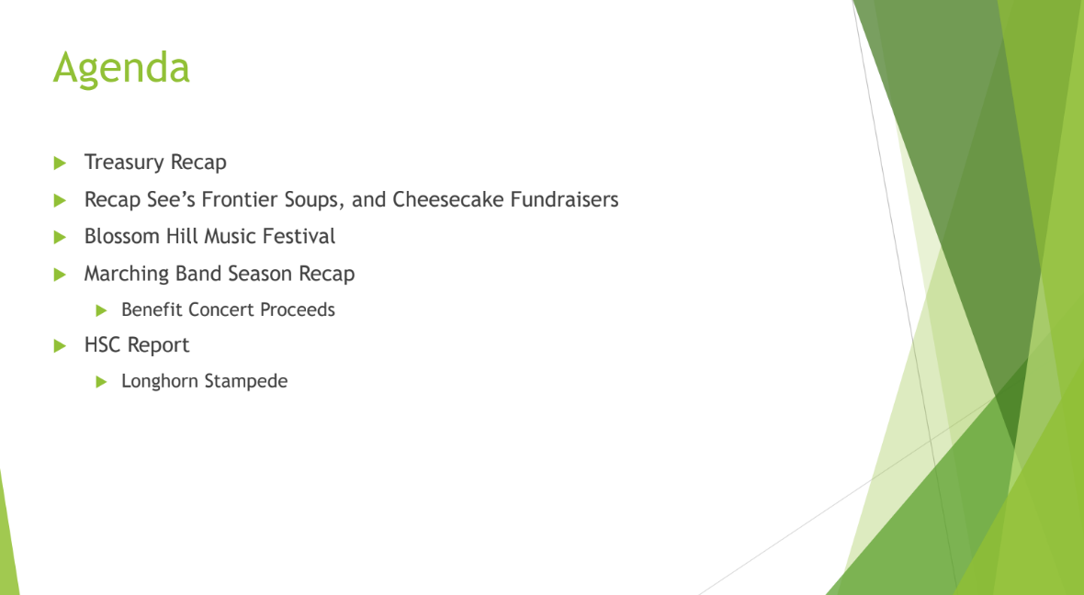

TREASURER REPORT:
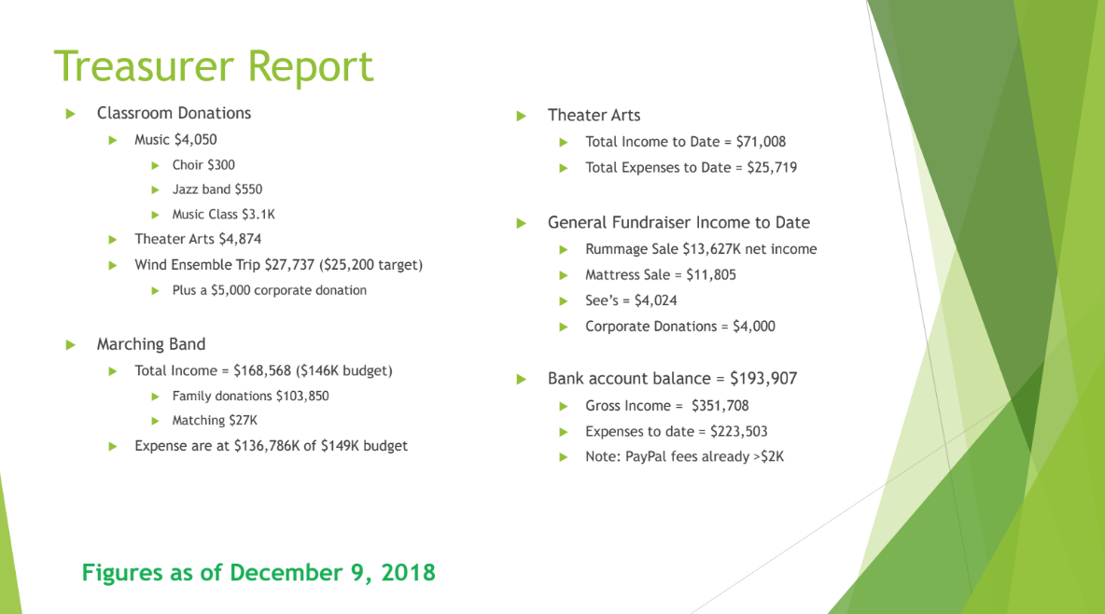
- PayPal fees = $2,000, should we continue to cover the PayPal costs for all of the year? Budget of $2,000 was met in November.
  - (Note PayPal for fundraisers has worked pretty well except for communicating to the Lead that we were using PayPal.)
  - Sonia will make a one page info sheet for how to have PayPal.
  - No one paid the upcharge to cover the fees, can we encourage the coverage?
- Joe observation: Was PayPal a pilot program?
- We must be clear about what we want and what we are doing with the donation process, people choose their donation process based on the method.
  - Writing a check is 8x as long for donations, but PayPal does take fee from the donations.
- Treasurer motions to double the budget and continue to cover PayPal fees.

CLASSROOM DONATIONS:
- Reminder made an impact on Jazz and Choir class donations.
- Corporate Foundation Grants from large companies.
  - (Example: Google gave each employee a voucher for $400 to apply to any 503c)

MARCHING BAND
- Family donation $103,000. Approx. $27,000 from corporate matching.
- Few expenses still out but should be covered.

THEATER ARTS
- Harvard gave budget description just for Fall events.
  - (5 revenue generating items total)
  - Theater is UP $2,000 on their budget.
  - Class donations are up.
  - 12th night was lagging in budget, but netted $1500.

GENERAL FUNDRAISERS
- Sees
  - $4,000 with 3,100 in fees. $900 profit, disappointing.
  - Make sure we make it CLEAR that it is for ALL ensembles and groups covered by PAPA.
- Cheesecake
  - $3000 net. is lower than he’s seen, but Scott feels good for a first outing.

CRAB FEED
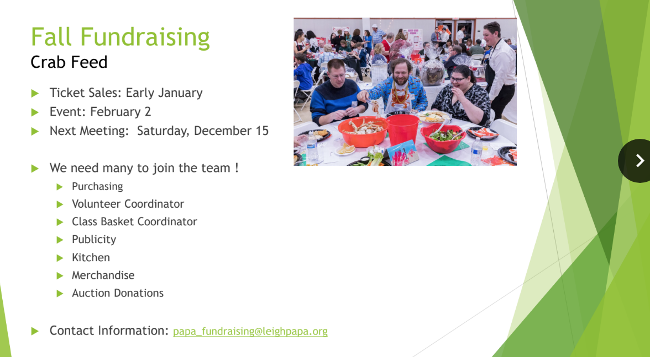
- Next meeting in Sat. Dec. 15.
- LOOKING FOR SHADOWS!! ESPECIALLY SOPHOMORE PARENTS.
  - Entertainment
  - Purchasing
  - Volunteer Coordinator
  - Class Basket Coordinator
  - Publicity
  - Kitchen
  - Merchandise
  - Auction Donations
    - Harvard will work on Tech Museum donations.

BLOSSOM HILL FESTIVAL 1/29/19
- Theme: Music from Around the World
- Tshirt Design: by end of week
- Shirt Sizes: Dartmouth is in working on Union and Leigh sizes.
- Food Plan: Darlene and Amy?
- Logistics: trailers for Union & Dartmouth, hopefully 1/28/19 evening.
- To facilitate parent volunteers

MARCHING BAND RECAP
- Family contribution is $20,000 over budget
- Participation rate is the same, people are paying more of the ask.
- RCC was SUPER expensive ($45,000)
- Staff increase
- HIGHS
  - Great attitude, participation
  - Parents and kids really enjoyed the show.
  - Successful benefit show for Butte County fire victims $16,000
  - Parade was successful
- LOWS
  - Parent volunteer challenges
  - Last show cancelled
  - Tech issues at the banquet.
- Benefit Show DONATION Information
  - Mr. Christensen interested in looking at other community based performance opportunities.
  - Alex also wants to make the benefit concert an annual event.

HOME & SCHOOL REPORT
- 12/15 scholarship deadline extended CSU scholarship
- Career expo
- SAT prep classes available again through College & Career Center info.
- Parent Ed classes
- Home and school club would like to renew Leigh HS Stampede.
  - The will take it on just to break even.
  - Looking for the community building event.

WIND ENSEMBLE UPDATE
- SNAP fundraiser now called Vertical Rays.
- Fundraising has tarted for Wind Ensemble. Inform families that this has begun.
- Wrestling team is also using Vertical Rays.
- Wind ensemble auditioned for “And You Were Heard” Program and was accepted to play.
  - Underrepresented composers (female, etc)
  - Could get newly written music, played by us and uploaded to their platform.

UPCOMING EVENTS:
- Winter Concert tomorrow December 11 at Louis B Mayer theater = 5:30 call time
- Saturday is CleanUp day 12/15 between 10 and 3.
Stay Connected: Keep up-to-date with what’s happening with Leigh Performing Arts
~ Band, Theatre, Choir, Marching Arts, Performances and Fundraising ~
Bookmark the Leigh PAPA website:
leighpapa.org

Fill out the New or Returning Student info form:
leighpapa.org/student-info/

Join the Facebook group:
www.facebook.com/lhspapa/

Follow us on Twitter:
https://twitter.com/LeighPAPA1

Volunteer at Performing Arts events and Fundraisers:
http://leighpapa.ivolunteer.com/
Next meeting: January 14, 2019.
ADJOURNED: 8:10 pm.

