Leigh High School
Performing Arts Parents Association

Minutes of Regular Membership Monthly Meeting
Meeting Date: Monday January 14, 2019
Called to Order: 7:08 pm
Attendees: 15
Conducted By: Stacey Taylor, President
Minutes: Kristine Grim, Secretary

December Meeting Recap – Stacey Taylor
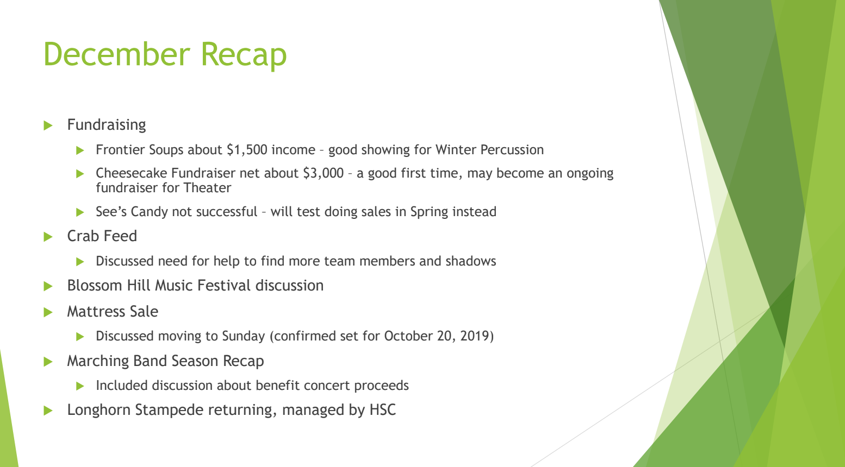
- Small meeting in December.
- December minutes, not yet available.
- Recap of smaller fundraisers
  - Frontier Soups = $1500.
  - Cheesecake fundraiser = $3000. Scott said it can be more lucrative.
    - Seemed some confusion over who was supposed to participate.
    - Better efforts to reach out to Music students to sell along with Theater students.
- Sees discussion took a bit of time.
  - Moving to Spring? Might do a test this year in Spring?
  - Something to talk about next month.
- Talked about Crab Feed we’ll talk about it again tonight.
- Discussion of Mattress Fundraiser and potentially moving it to Spring? to a Sunday?
- Sunday Oct. 20th is available and confirmed.
- September PAPA Mtg. will be a big kickoff with food and high interest.

CRAB FEED: Nathalie Goriganec
- Sherry will give her update when she arrives.
- Still need Team Lead for Volunteer Coordinator
  - Make sure students are on task
  - Documentation and script to follow
- Need help with Publicity at Middle School and Community,
- Would love shadow for Kitchen, Auction, and Lead.
  - Sherry’s last year, Lisa’s last year so it is important to have time to get involved in the preparation
  - Ongoing problem for music and theater of downward spiral of volunteering.
  - We need to reach out personally to those we know especially sophomore parents.
  - We can put out another email, but no one has reached out to Lisa and they’ve been going out since October.
- Tickets: 42 sold, but there was a glitch in the process between treasurer, communications, and the ticket lead and that has been corrected and documented.
  - Last year we counted the donation of the staff tickets at cost not at the &50 selling price.
  - We can cover 3 staff. Staff tend to bid on the auction items.
  - Discussion RE: VIP tickets we use. Do we really think we need to invite people, outside of our teachers?
    - PAPA coaches haven’t been considered in the VIP tickets. Should/could we, as a group, invite and/or pool our monies to sponsor our 4 main coaches? Not from Crab Feed budget of course.
  - 3 Directors +1, Dr. Bravo +1, check with Lisa about what we did in past years.
  - APs are put in the same pool with teachers, ask Lisa about Kara.
  - This is a discussion for the Crab Feed committee the board has allocated their funds and it is theirs to decide how much they can afford in comped tickets. Stacey would ask that committee members reach out to someone they know and ask their thoughts on that.
- Sherry Ayers: donation report for auction.
  - Up to $16,000, but came in slowly.
  - Harvard brought Tech donations
  - There are a couple more volunteers who have stuff to tally up so we are on target.
  - Sharks tickets, Warriors tickets, 49ers tickets. Made a lot of progress in the last week.
  - Email reminder brought forward 2 or 3 more people for volunteering.
- Mr. C asks about electronic or paper signups for volunteers?
  - Everything is set up electronically in iVolunteer.
  - We will share that with Alex for the students who are volunteering to be servers.

SNAP FUNDRAISER with Vertical Rays
- Creates anxiety and Receiving negative response from parents about the brow-beating and competitive environment.
- Frustration that the host takes 25% approx. off the top for fees.
- Employer match is hard with a Vertical Rays kind of fundraising.
- Stacey presents option of a letter campaign to family and friends instead.
  - A group of us can craft an “ask letter” detailing our need, personalized by the student.
  - Greenlake Rowing in Seattle does this with a “ticket and stub.” You send back your info w/ donation and keep the stub with all the info on it. It has their logo and she writes a personal note.
  - There is a postage cost involved in that.
  - On the current PayPal donation there is a note area that designates the donation for a specific ensemble.
  - Incentives for donating?
- Diane asked about marking funds when donating through PayPal. Stacey suggested making a note to allocate the funds, the treasurer will see this.
  - PayPal is a problem for matching donations because it doesn’t provide a specific enough receipt for some company matching.
  - Mr. C asks if there is a way PAPA can furnish the appropriate receipt on our own?
    - Yes, Gil has a template to add the donation button to the website page. Treasurers are issuing them manually now. It is a little more work, but not overwhelming, Everytime someone goes to a donation page, there is a list of demographic data (name, email address, student, grade, amount, we could add ensemble) sends it to the credit card processor and the data goes to a local form that PAPA can look at.
  - Gil and Stacey will talk off-line and perhaps bring a demo to the board.
  - Board is supportive of this change to a letter campaign.

FIRST AID FUNDRAISER
- Discuss at February Meeting
- Stacey will check if she submitted the paperwork yet as a trial.
GRADUATION FUNDRAISER
- Discuss at February meeting.

CORPORATE CAMPAIGNING

- $27,000 in corporate matching for Marching Band, will probably end up over $30,000.
- $5,000 for Wind Ensemble
- $0 for Winter Percussion
- $2,000 from Allstate in September
- $2500 from Safeway
- $5,000 grant from Angela’s company through Silicon Valley Bank. Let’s remind parents there might be grants at their own companies.
- Rita trying to get $2,000 for Wind Ensemble from Super Duper Burger.
- Area we struggle is with WP because of lack of engagement or lack of support from the percussion associated type of companies.
- Stacey and Rita are working on a template letter for donations and grants for others to follow for writing grants. We’ve always been looking for a parent who knows grant writing to write us some.

MICHAEL BROOKS SCHOLARSHIP
Review of Scholarship from Stacey:
- A Leigh grad in the 80’s who died in a car accident a few years ago, active in the community, had a band, was enthusiastic about life and music.
- His friends established a fund for scholarships, Last year this group asked for our help in identifying recipients: they gave $4500 over 3 scholarships.
Joe shared this backstory:
- The Michael Brooks Scholarship needs a financial home. It is personally funded, but they are researching corporate funding and therefore need the coverage of a 501(c)3 like us.
- Last year the district housed the monies in a custodial account. Corporations are changing rules and looking for 501(c)3 institutions to be sure funds are used appropriately.
- The scholarship committee would like PAPA to be it’s functional custodian. PAPA would be its legal home, accept donations in its name.
- The “Scholarship Team” (his friends) would do the fundraising and application reading and selection. PAPA would execute the checks.
Discussion of our involvement:
- PAPA’s concerns would be the liablility of being a check writer for an outside entity.
- Casey Broberg has been the point person, brought to PAPA by Ed Schultz. He made it clear they are open to a collaborative relationship.
- The application seems similar to our Senior scholarship, however this one is only open to those pursuing study in music, no drama or other performing arts
- Joe is proposing a collaborative relationship with them.
- Joe and Stacey along with whoever else should be involved would draft a letter outlining responsibilities, logistical issues, end of relationship rules, etc.
- Stacey shared history of 2018 scholarship event, it did not create any concerns except a worry about being responsible for the monies and our own status.
- Concerns about this relationship: oversight = theoretical risk of misuse of the scholarship. Can be addressed by transparency.
  - All non-PAPA persons involved are identified and must agree in writing to the ethics policy of PAPA.
  - Formalize their decision-making group.
  - Substantiation and documentation similar to our own scholarship.
  - We would expect the same level of transparency as the PAPA scholarships and information regarding decisions.
- Extrication clause in the letter: monies dispersed in final scholarship or forwarded to a 501(c)3 that validates with PAPA that they will follow the legal distribution of funds according to California law.
- There were low application numbers for the Senior scholarship and this one, could have been from low advertising.
- Nathalie commented about the requirement of declaring scholarship monies to colleges for financial aid packages.
- Gil asked if the name will remain the Michael Brooks Scholarship for purposes of banking?
  - They will be advertising and fundraising under the name “The Michael Brooks Scholarship,” but for donation logistics it will be a “directed donation” under Leigh PAPA, noted in the memo
  - For money management it will be marked and a separate line item, a liability account, they have about a $100.00 carry over. Accounting books and records would have “x” amount set aside for that, similar to the Theater for the Future.
- Another issue for the letter is what if they get so big they have an endowment?? Maybe language to re-address relationship if it comes to that.
- The scholarship raises about $5000 a year, with about 40 donors a year.
- Joe is researching the tax issues for 1099 Miscellaneous etc. It should not have a noticeable impact on the treasurer, “it’s just a little bit more of what we do already.”
- Angela asked: Can the letter be renewable, say after 3 years so there is an out for PAPA.
  - Joe planning on a letter year to year, perpetual, but able to be end after a particular scholarship cycle.
Gentleman moves that PAPA become the home for the Michael Brooks Scholarship.
- Joe re-words the motion: to let PAPA enter into a working partnership with the Michael Brooks Scholarship that we sponsor and operate as part of PAPA responsibilities.
- Diane Hofstetter seconds the motion as amended.

THESFEST and THESCON (Upland) REPORT
Is there anything the board can do to support it?
Student run, no report from ACTS.

BLOSSOM HILL FESTIVAL
- Mr. C thanks Diane for keeping him on top of all the information.
- The BH Festival is totally on track: t-shirts ordered, approval for picking up equipment from other sites the night before and returning the night of the event.
- We need drivers for 2 trailers:
  - 1 trailer to Dartmouth
  - 1 trailer to Union
- Schedule: check-in & t-shirts for middle school students @ 3:00 in front of gym or outside cafeteria, practice at 3:30.
    - eat @ 5:30
    - seats @ 6:45
    - show @ 7:00
- Snacks are for the HS kids who will be here straight through the day.
- Information to get Baked donations from other sites requested, sent to Mr. C ASAP.
- Stacey suggests selling mugs @ Blossom Hill Festival = M. Martin
- Leigh students get t-shirts in class prior, t-shirt arrival targeted for Jan. 24th. Roster by size is best, but whatever works for Diane.

Mr. C REPORTS
- $13,116 in donations to the benefit concert, cards and monies given to Alex.
  - He is getting the card signed and will be delivering by the weekend.
  - It MUST be put in the safe in the front office or it will not be insured.
- Last Tuesday, Cameron Poole, former involved musician in the Leigh program, passed away. Class of 2015-16.
  - Alex would like a special acknowledgement and dedication of One Light Beautiful at the next concert.
  - He will draft a memorial response for the concert.
  - Could we make a donation somewhere on his behalf? Should we send flowers?
  - Concerns that we don’t know the details of his death and there should be a reach out to the family about where they are in the grief process.
WINTER PERCUSSION
- Winter Percussion had a successful bake sale shared that an adult should be present at every bake sale.
  - Shared an incident of a single, mildly disturbed individual interacting with the students, creating an unstable and uncomfortable situation.
  - Took about 10 minutes to move him on his way. Susie Woodford suggested 2 adults from her Girl Scout cookie experience.

NEW YORK TRIP - WIND ENSEMBLE
A composer that Mr. C idealized, Johann DeMay, will be the clinician for Wind Ensemble and will work on the 5th movement of his symphony directly with them. WE will also have a joint rehearsal with a HS from Corona, CA. They’ll play together and socialize on a dinner cruise together.
Stacey has not seen the final invoice come through QuickBooks.

DRAMA DEPARTMENT
Big Fish audition was the first show to use the new online signup process. It was successful and thanks to Rita who was instrumental in overseeing the students.
All paperwork and information was taken care of online prior to the audition day which made data collections easy and more accurate.

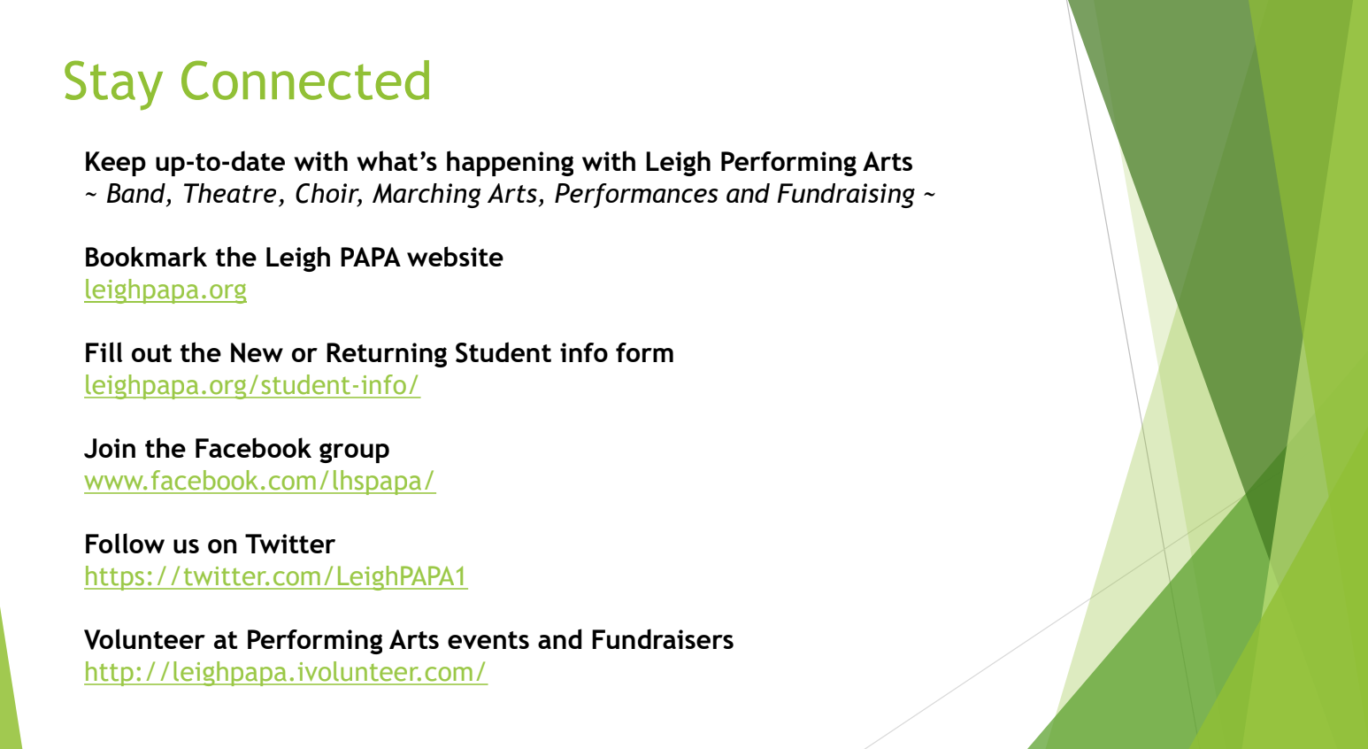
Next meeting: Monday, February 11,2019.
Adjourned @ 8:16.

