DRAFT
Leigh High School
Performing Arts Parents Association

Minutes of Membership Monthly Meeting
Meeting Date: Tuesday Nov 15, 2018
Called to Order: 7:05 pm
Attendees: approx. 20
Conducted By: Stacey Taylor, President
Minutes: Kristine Grim, Secretary

HAUNTED HOUSE RECAP
$4,711 preliminary total.
May try one pass for all 3 next year to simplify tours and ticketing.
There were a few hiccups this year with VBO.
Scott D. enjoyed observing this project and learning about it here at Leigh.
Cut back on times offered this year, may have impacted
Mid-week Halloween, not a factor in lower total.
Updated total monies at next meeting,

MATTRESS FUNDRAISER RECAP
$11,805 back to PAPA
20 more beds sold would have reached our $20,000 goal.
Only 48 referrals out of 300 PAPA students. This is area for improvement.
Sam ST. Germain feels like multiple sales in the area (Los Gatos, Fisher,
Leigh) provides cumulative advertising effect.
Drawback = No student availability due to marching band & SAT.
Should we move it to Spring?
No, people are waiting for our scheduled fundraising items.
Moving it to Sunday??
This is a definite possibility.
More volunteer availability and student participation.
Keeping it in October means getting 100 people to the informational meeting in September. This = $500 from the fundraising company.

FUNDRAISING
(See’s, Soups, & Cheesecake)
Online ordering available for ALL 3, with PayPal or Green Box option.

SEE’S CANDY
DUE tomorrow 11/15, distribution week of 11/26.
Should we move Sees to Spring? (Cheer sells in Fall as well.)
Moving to Spring provides Valentine’s? Mother’s Day? Easter?
Teacher Gifts? Etc.

SOUPS
Forms due 11/30, distribution in mid-December.

CHEESECAKE
Forms due 11/30, distribution week of 12/17.
NO SHIPPING!

Upcoming CHEFS NIGHT AND BAKE SALES
Panda Express 11/15
Safeway Bake Sale 11/17
Armadillo Willy 12/2
Mooyah 12/10
Safeway Bake Sale 12/22

CRAB FEED “Crabby Crew”
11/28 Planning Mtg.
We Need Shadows for next year! Senior parents are leaving! Plug @ the Banquet!
Purchasing
Volunteer Coordinator
Class Basket Coordinator
Tighter guidelines for baskets, THEME baskets?
Publicity
Kitchen Coordinator
We are looking into a partnership w/ Chef Toledano and the Foods
class for prep cooks and plating volunteers.
Merchandise Coordinator
Auction Donations
What about coordinating with Art department for painting and support in Theater and for fundraiser signs and decoration for service hours? Could work for CSF or outside hours needs.

TREASURER REPORT
New Reimbursement & Purchase Request Forms
Collected requester info saved
Allow attachments for better record keeping
Require a signature
Allows for multiple items (no excel grid)
Each item to be added has a drop box for the G/L activity code
(Should help us use the correct codes.)
Links to Reimbursement form and Purchase Request Form on slide

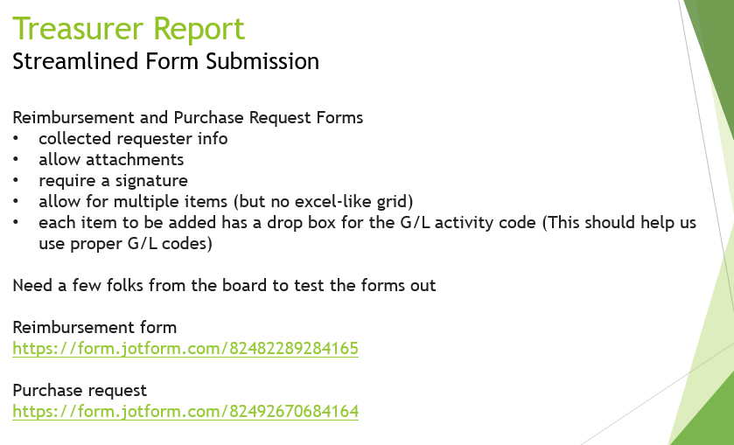

MR. CHRISTENSEN REPORT
Last comp cancelled due to smoke
Working with 4 other directors for a benefit show, Tues. after the break.
Tues. 27th 7:00pm to benefit the Camp Fire victims
Diane Hofstetter coordinate logistics for OTHER schools to get equipment.
CASH, TEXT, GIFT CARD donations.

MR. DI LORENZO REPORT
Waitress field trip was awesome.
Discuss possibility of an “age-appropriate” rating system for field trip shows.
12th Night Tech week right now. Jazz quartet is example of coordinating between
Performing Arts.
12th Night performs the first 2 wks in Dec.
Please put ticket information on the top of PAPA email.

BLOSSOM HILL FESTIVAL (Rita Jaworski)
Jan. 29, 2019.
Deadlines: Shirt design: before Winter Break, Count immediately afterward.
Food: Amy & Darlene
Logistics: Trailers for the Middle Schools.
Moving items Monday Night instead of Tuesday morning is easier on
the parent volunteers

CONCERTS (Rita Jaworski)
12/11 – SCU Louis B. Mayer Theater
12/13 – PAC Choir, Jazz 1, Jazz 2
Food is trickier at SCU.
Instrument transportation coordination.
Set up/Tear Down iVolunteer needs to go out.

UPCOMING EVENTS
SPRING MUSICAL
THEATER: Spring auditions week of 12/10
MUSIC: Pit auditions are online.

MARCHING ARTS
LG Parade 12/1
Winter Guard and Percussion Auditioning NOW.

HSC
Teachers have been working without contract since 8/31/18.
An agreement seems to have been reached.
Voting will be end of November/early December.
Cell phone hotels available to teachers.
DC trip in Jan. (10 spots left)
Pumpkin Chunkin Physics presentation: 12/7 @ 2:30

AREA REPORTS
Operations: December 15th?? workday, clean up, clear out, reorganize, store.

Winter Guard size (20-22) and Winter Percussion size (42) final clinic Thursday.
Numbers are looking good

NEW IDEAS
Diane H. - Holiday Fairs
Needs a champion, crafters signup in April.
Income from table fees, booth fees, 10% of sales.

Angela and Joe thank you for support and help this Fall for all the Treasury help.

